**THE FRIENDS OF BETHEL SKETTY CEMETERY NEWSLETTER**

*Issue 1: July 2023* [*bethelsketty@gmail.com*](mailto:bethelsketty@gmail.com)

TOP NEWS

**Foreword by Chairperson**

It is is pleasure to introduce the first issue of the Friends of Bethel Sketty Cemetery newsletter. We have come a long way on our journey and there is still much to do in trying to safeguard our relatives' and friends' resting place. We are aiming to launch our website soon and to produce more newsletters.

On behalf of the Committee may I thank you all for encouragement and continued support in our venture.

Many thanks Des Barnett

# THE NEWS

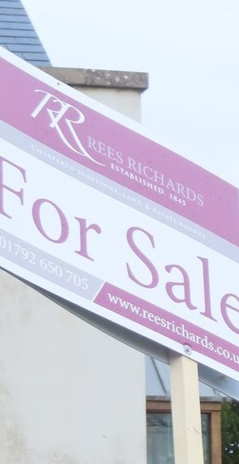

As you are aware, Bethel Chapel, the caretaker’s house and the cemetery were put up for sale last summer. A

LOREM IPS CONSECTE UT PHARE AENEAN E

WELCOME TOU OUR COMPANY

UM DOLOR SIT AMET, TUR ADIPISCING ELIT. RA JUSTO NISI.

IT ODIO,

potential purchaser made an offer, which was T accepted but the sale seems to have stalled. We L understand that the purchaser is unable to make contact with the Trustees of Bethel. Rees Richards,

the estate agents, have removed the For Sale signs from the site and as far as we know have now taken the sale of Bethel off their books.

It seems no-one that knows what the current situation is regarding the sale. There have been several complaints submitted to the Charity Commission and we understand the Charities Commission are now investigating the Trustees. This is perhaps why the sale has been put on hold. We will endeavour to keep you informed of any updates regarding the sale.

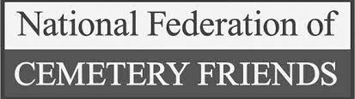

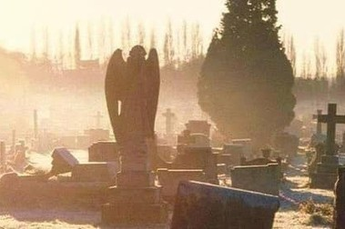

## FIONA'S VISIT TO THE AGM OF NATIONAL FEDERATION OF CEMENTERY FRIENDS

Since we started our fight, we have been extremely fortunate to have support from Colin Fenn the vice chairman of the National Federation of Cemetery Friends. We must give much thanks. He and the National Federation have guided us through many of thre complex laws regarding cemeteries. Here is Fiona's account of her visit

“Last month I went to the AGM of the National Federation of Cemetery Friends held in Brompton Cemetery in London. I am so pleased that I made the effort to go. An item on the agenda was the vice- chairman's report which was given by our good friend, Colin Fenn. The plight of Bethel was highlighted and so many people came and talked to me to offer their support and to say how shocked they are by what is happening at Bethel.

We had an hour and a half guided walking tour of the cemetery including the catacombs which are under ground Since we commenced our cause, we have been extremely privileged to have the support

from Colin Fenn Vice chair

of National Federation of Cemetery Friends . He has guided us through some of complexities of Laws regarding cemeteries.

Here is Fiona's account of her visit

“Last month I went to the AGM of the National Federation of Cemetery Friends held in Brompton Cemetery in London. I am so pleased that I made the effort to go. An item on the agenda was the vice-chairman's report which was given by our good friend, Colin Fenn. The plight of Bethel was highlighted and so many people came and talked to me to offer their support and to say how shocked they are by what is happening at Bethel.

We had an hour and a half guided walking tour of the cemetery including the catacombs which are underground and house the coffins of very rich people from about 130 years ago until that method of burial fell out of favour. I saw a number of the famous graves including Emmeline Pankhurst and the Sioux Indian Chief, Lone Wolf.

Our Facebook page was discussed and I was told that people's contributions on there would be likely to be regarded as evidence that we have good support from the local community, relatives and so many people and all your comments could prove to be highly influential going forward. I was absolutely delighted to hear that and would like to thank everyone who has contributed to our Facebook page. Please keep your contributions coming.”

We were covered in the NFCF's newsletter in June '23. [Download here](https://mcusercontent.com/2a34db837d653d5b6e6a4e5e4/files/7b9d3f18-6121-542c-eee1-814786018151/nfcf_newsletter_51.pdf) If you can't view from the download, drop us a line and we can send you a file.

**ISSUE 1: JULY 2023** [bethelsketty@gmail.com](mailto:bethelsketty@gmail.com)

LOonretmheipwseuemkednodloor fsiAt parmil e1ts, tcoannsdecStuentduar yadipisicing elit, sed do e2inuds,mwode tecmelepborraitnecdididPuanlmt utSulanbdoarye ewt idtholore magna aliqua. Ut Fenriiemndasd mpliancimingvefnlioawme,rqsuiosnnotshteriurdfeaxmericlyitation ullamco laboris ngirsaivuetsaalinqduipotehxeeras.coWmemaoldsoochoandsepqeuoapt.leDuis aute irure dolor in rweiptrhehneoncdoenrint einctvioolnupbtuattetoveolkit teismsee ctiollulamy dolore eu fugiat nulla pflaorwiaetrusr.on a number of graves. We are

extremely grateful to thhose e magna aliqua. Ut enim ad minim veniam, quis nostrud exercitation ullamco laboris nisi ut aliquip ex ea commodo consequat.

Duis aute irure dolor in reprehenderit in

voluptate velit esse cillum dolore eu

fugiat nulla pariatur.

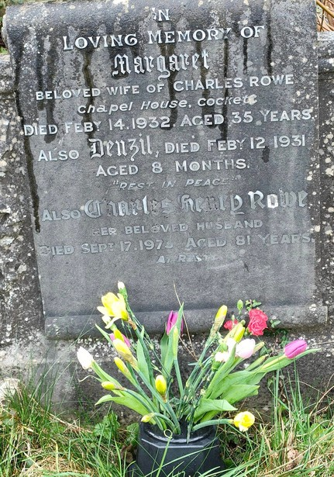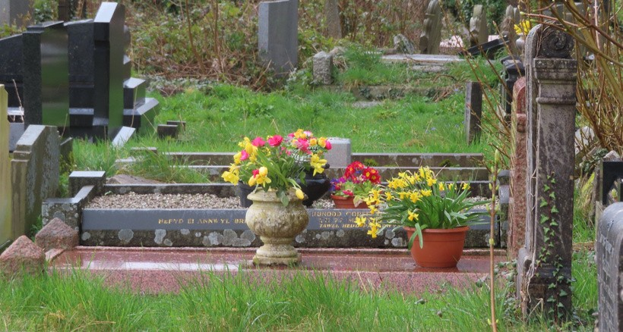

**FLOWERING SUNDAY**

On the weekend of Saturday 1st and Sunday 2nd April we celebrated Flowering Sunday by placing flowers on family graves. We are grateful to those who attended to make it a special occasion. We had those from the local community laying flowers as a mark of respect.

We also supported

ancestral graves.

those looking

for family and

**By Janet Neilson**

**By Jane Turnbull**

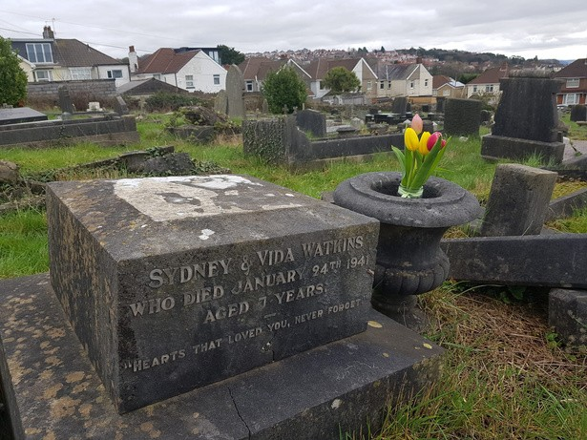

**By Liza Ludbrook**

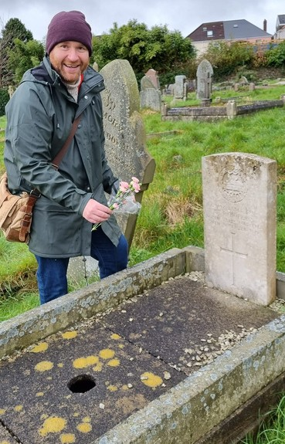

**Councillor James McGettirck placing roses at our CWGs**

Since this wonderful day the grounds were left uncut until recently. Even with the grass cut you still need to be careful. However, no doubt it will not be long before it is overgrown again. If tending to a grave, please help and try and cut the grass surrounding your plot.

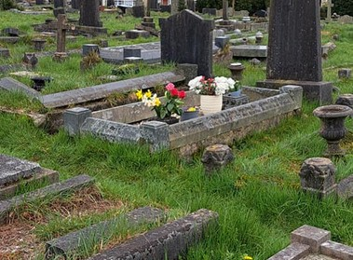

**by Christine Clarke**

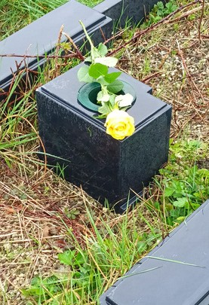

**by Des**

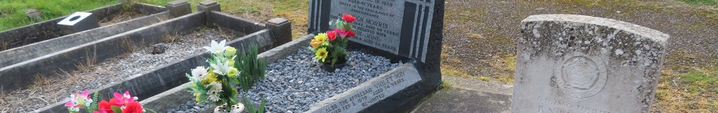

**ISSUE 1: JULY 2023** [bethelsketty@gmail.com](mailto:bethelsketty@gmail.com)

## Celebrating National Cemetery Week

**Celebrating Commonwealth War Graves Week**

**D**uring the week 20th to 28th May 2023 we celebrated Commonwealth War Graves Week. Through our Facebook page we not only remembered the 20 souls in CWGs at Bethel, but also those who did not return home and are remembered on family stones. We have discovered some of their stories and they are full of emotion and acts of bravery as well as sadness for their families. These stories bring home the importance of safeguarding their memories and resting place. We have set ourselves the aim of finding all memorials of those who did not return home. We also have 25 people who died during The Swansea Blitz and are buried at Bethel. It is important that we remember them too. Again, we will be looking to locate their graves to ensure they are also respected.

Here are three people who did not survive the wars.

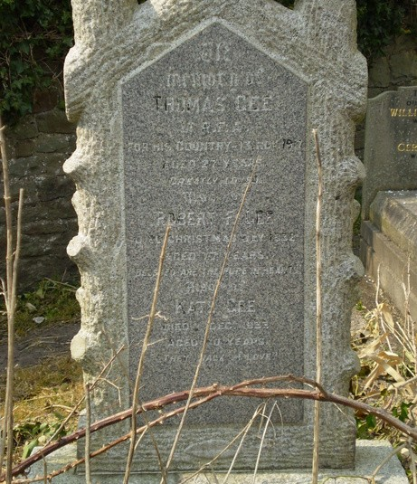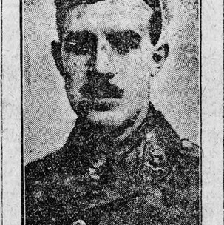**Lieutenant Thomas Gee,** served with the

122 Brigade Field Artillery, 38th Welsh Division. He would have served during the battles of The Somme and likely the battle of Ypres.

Lieutenant Gee was also Mentioned In Dispatches.

## Lieutenant John Trevor Hamilton was an

S.O.E operative in France during WW2. He was captured and killed by the Gestapo. He has no known grave. (Thanks to Paul McCue for the photo. [Paul McCue Books](https://www.paulmccuebooks.com/) ). Memorial on Family Headstone.

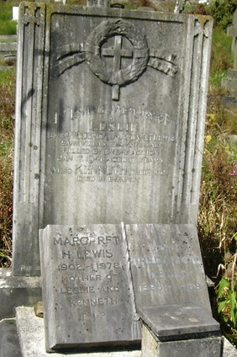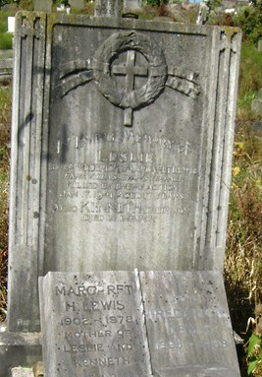**Civilian Death during the Blitz Leslie Lewis**

of 14 Evans Terrace, aged 17.

Found at 14 Evans Terrace, 23/01/1941

**ISSUE 1: JULY 2023** [bethelsketty@gmail.com](mailto:bethelsketty@gmail.com)

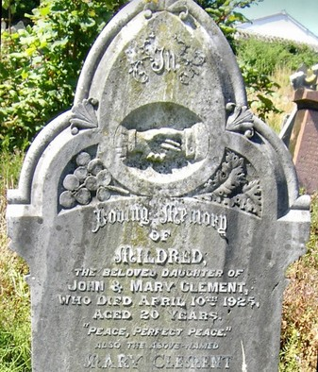

**Celebrating National Cemetery Week**

On June 3rd to June 11th we celebrated National Cemetery Week. Each day via our Facebook page we posted pictures of different styles of memorials with specific symbols. We posted these on our Facebook page giving an explanation around their meaning. We thank Gareth Jones for the research and posting them. Here is a couple of these postings.

## Handshakes

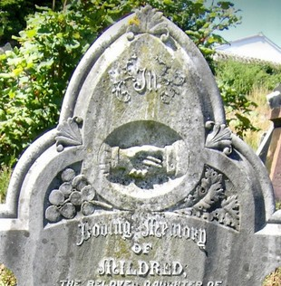In the case of gravestone symbolism, **handshakes** can mean a final farewell or an eternal bond between the living and the dead. Sometimes one hand in a handshake is very stiff, showing that the person is dead, while the other hand has bent joints, indicating that the person is alive. The hand on the left is usually the one belonging to the deceased. This symbol of farewell between the living and the dead is often accompanied by the words Gone but not forgotten, Rest in Peace, or Goodbye.

## Urns

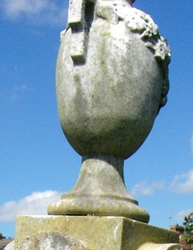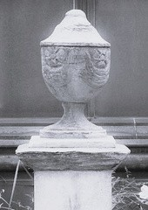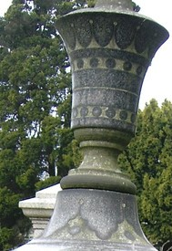**The urn** symbolises death itself. The Greeks used the urn as a symbol of mourning, since it was often used as a repository for ashes of the dead. The urn is also described as a symbol for the soul, immortality or penitence. These photos of some examples in Bethel.

In future newsletters we will mention other types of memorials. We will also have more symbols and explanations on our web page.

If you wish to let us know of an interesting symbol at Bethel or wish to have a symbol explained, just drop us a line preferably with a photograph, plot number or something to help us identify the grave and symbol.”

**ISSUE 1: JULY 2023** [bethelsketty@gmail.com](mailto:bethelsketty@gmail.com)

# Committee of the Friends of Bethel

The Committee of the Friends of Bethel Sketty Cemetery was set up after Dr Barbara Morris arranged for a meeting of families at the Vivian public house back in August 2022. Since then the Committee has been working hard, trying to get answers to all your questions. As well as looking into the complexities of the sale of Bethel we are trying to raise awareness of our plight to those in authority, and to promote the cemetery itself. The committee are currently a group of six, with Dr Morris stepping down due to personal reasons in May 2023. We are very grateful to her for starting us all on this journey and we wish to thank her for her commitment.

If you wish to become involved with the committee, we would like to hear from you, especially if have an understanding of the following: property law, contract law, charity law, canon law, environmental issues, Welsh translation, writing or IT skills or have an interest in family history. Please don't be shy in coming forward as we are all on a steep learning curve and will not be judging you. If interested please contact us at [bethelsketty@gmail.com](mailto:bethelsketty@gmail.com)

# Questions

During the week we celebrated National Cemetery Week we asked questions on our Facebook page. If you felt you did not wish to answer on a public forum, you can email us.

June 4: In one sentence, what does Bethel mean to you? June 5: Do you remember the first time you visited Bethel?

June 7: Do you have a favourite photograph of Bethel and would you be happy to share it with us please?

June 8: Do you have evidence of your family's right to be buried at Bethel?

June 9: If we sue the Trustees for breach of contract, would you consider joining us in a group litigation scheme?

June 10: Why do you visit Bethel and other than your own family grave, do you have a favourite place there?

June 11: Do you support us due to family connections, out of general interest or is it disrespectful not to safeguard the cemetery?

**ISSUE 1 : JULY 2023**

[bethelsketty@gmail.com](mailto:bethelsketty@gmail.com)

# The Old Ground

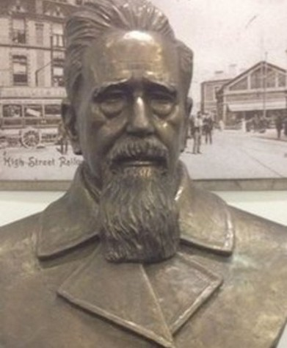

The oldest part of the Cemetery, known as the Old Ground, has a number of interesting headstones and memorial engravements. We also have CWGs located here as well as historical graves such as that of the Reverend Griffith John who spent 50 years as a missionary in China. We have already heard from several of our Friends who have family graves in the Old Ground but if you have a family grave there and have not contacted us about it we will be delighted to hear from you. If possible please give us details of the names, relevant dates and locations.

.

## Griffiths John

’

**Donations**

We’ve had several offers of donations from Friends, to help with the costs associated with running the Friends group, associated activities and maintenance of the cemetery. At the moment we are only incurring fairly minor expenses, and individual committee members have been able to cover these costs. With the cemetery still owned by the Trustees, it remains their obligation to maintain the cemetery and we are unable to initiate works due to legal issues. If and when we can take responsibility for the Cemetery we will then pursue avenues for funding.

If and when we need financial help we will put out an appeal and if you are able to help then we will be very grateful.

’

**It just remains for us to once again say a special thanks to Colin Fenn, the National Federation of Cemetery Friends and of course you - our Friends. If you have not yet done so please check out our Facebook page and encourage your family and friends to join us.**

**Thank you**

[Facebook page](https://www.facebook.com/groups/1287088055384929) [bethelsketty@gmail.com](mailto:bethelsketty@gmail.com)

